**INDUSTRIAL MIST FANS:**

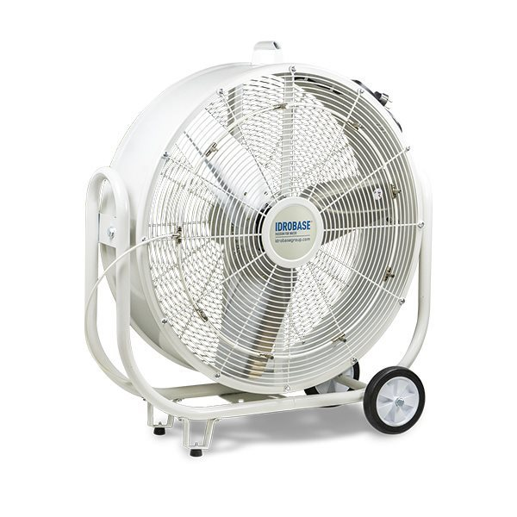

**Price: 13,000.00**

The Industrial Mist Fan is a heavy-duty cooling solution designed for large-scale industrial and commercial applications. This fan combines powerful airflow with a high-pressure misting system, effectively lowering temperatures and increasing humidity in hot and dry environments. With its rugged construction, corrosion-resistant coating, and adjustable misting system, the Industrial Mist Fan is ideal for factories, warehouses, construction sites, and other industrial settings where reliable and efficient cooling is crucial.

**Key features of industrial mist fans include:**

* **High-Volume Airflow:** Designed to cover large areas with powerful airflow.
* **Integrated Misting System:** Releases fine mist to cool and humidify the air.
* **Durable Construction:** Built with robust materials to withstand heavy-duty use in tough environments.
* **Adjustable Speed:** Allows control over fan speed for varying cooling needs.
* **Large Water Reservoir:** Supports extended misting without frequent refills.
* **Energy Efficiency:** Consumes less power compared to air conditioning systems.
* **Corrosion-Resistant:** Suitable for industrial environments with harsh conditions.
* **Wide Coverage:** Often features oscillation to cool larger spaces.
* **Portable or Fixed Design:** Can be moved or mounted depending on the application.